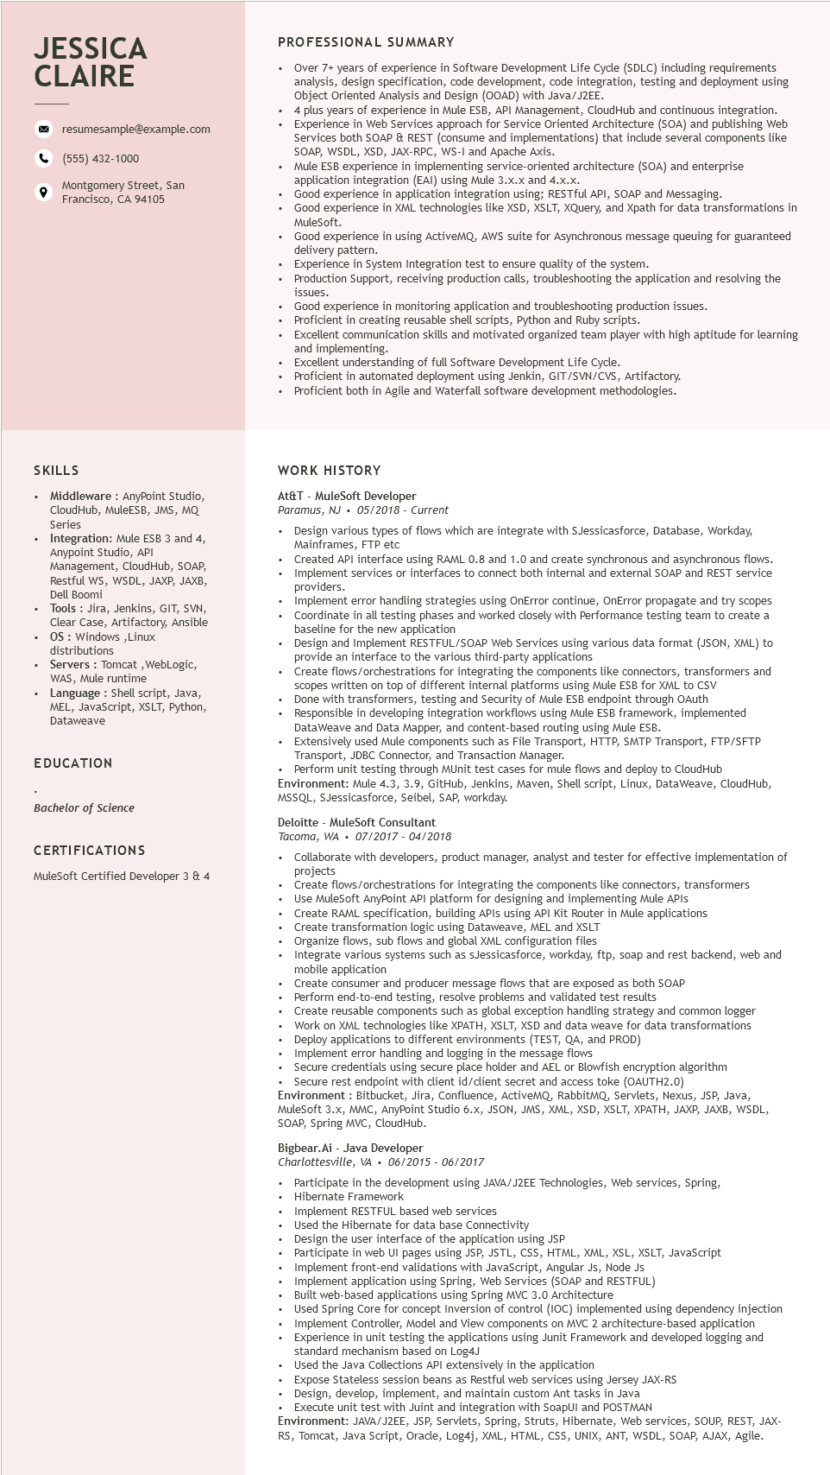
JESSICA CLAIRE
resumesample@example.com
(555) 432-1000
Montgomery Street, San
9
Francisco, CA 94105
PROFESSIONAL SUMMARY
...
Over 7+ years of experience in Software Development Life Cycle (SDLC) including requirements analysis, design specification, code development, code integration, testing and deployment using Object Oriented Analysis and Design (OOAD) with Java/J2EE.
4 plus years of experience in Mule ESB, API Management, CloudHub and continuous integration. Experience in Web Services approach for Service Oriented Architecture (SOA) and publishing Web Services both SOAP & REST (consume and implementations) that include several components like I and Apache Axis.
SOAP, WSDL, XSD, JAX-RPC, WS-I and
Mule ESB experience in implementing service-oriented architecture (SOA) and enterprise application integration (EAI) using Mule 3.x.x and 4.x.x.
Good experience in application integration using; RESTful API, SOAP and Messaging.
Good experience in XML technologies like XSD, XSLT, XQuery, and Xpath for data transformations in MuleSoft.
Good experience in using ActiveMQ, AWS suite for Asynchronous message queuing for guaranteed delivery pattern.
Experience in System Integration test to ensure quality of the system.
Production Support, receiving production calls, troubleshooting the application and resolving the issues.
Good experience in monitoring application and troubleshooting production issues. Proficient in creating reusable shell scripts, Python and Ruby scripts.
Excellent communication skills and motivated organized team player with high aptitude for learning and implementing.
Excellent understanding of full Software Development Life Cycle.
Proficient in automated deployment using Jenkin, GIT/SVN/CVS, Artifactory.
Proficient both in Agile and Waterfall software development methodologies.
SKILLS
Middleware: AnyPoint Studio, CloudHub, MuleESB, JMS, MQ Series
Integration: Mule ESB 3 and 4, Anypoint Studio, API
Management, CloudHub, SOAP, Restful WS, WSDL, JAXP, JAXB, Dell Boomi
Tools: Jira, Jenkins, GIT, SVN, Clear Case, Artifactory, Ansible OS: Windows, Linux distributions
Servers: Tomcat, WebLogic, WAS, Mule runtime
Language: Shell script, Java, MEL, JavaScript, XSLT, Python, Dataweave
EDUCATION
Bachelor of Science
CERTIFICATIONS
MuleSoft Certified Developer 3 & 4
WORK HISTORY
At&T - MuleSoft Developer
Paramus, NJ 05/2018 - Current
• Design various types of flows which are integrate with SJessicasforce, Database, Workday, Mainframes, FTP etc
.
Created API interface using RAML 0.8 and 1.0 and create synchronous and asynchronous flows. Implement services or interfaces to connect both internal and external SOAP and REST service providers.
Implement error handling strategies using OnError continue, OnError propagate and try scopes Coordinate in all testing phases and worked closely with Performance testing team to create a baseline for the new application
Design and Implement RESTFUL/SOAP Web Services using various data format (JSON, XML) to provide an interface to the various third-party applications
Create flows/orchestrations for integrating the components like connectors, transformers and scopes 5 written on top of different internal platforms using Mule ESB for XML to CSV
Done with transformers, testing and Security of Mule ESB endpoint through OAuth
Responsible in developing integration workflows using Mule ESB framework, implemented DataWeave and Data Mapper, and content-based routing using Mule ESB.
Extensively used Mule components such as File Transport, HTTP, SMTP Transport, FTP/SFTP Transport, JDBC Connector, and Transaction Manager.
Perform unit testing through MUnit test cases for mule flows and deploy to CloudHub Environment: Mule 4.3, 3.9, GitHub, Jenkins, Maven, Shell script, Linux, DataWeave, CloudHub, MSSQL, SJessicasforce, Seibel, SAP, workday.
Deloitte MuleSoft Consultant
Tacoma, WA⚫ 07/2017 - 04/2018
Collaborate with developers, product manager, analyst and tester for effective implementation of projects
Create flows/orchestrations for integrating the components like connectors, transformers
Use MuleSoft AnyPoint API platform for designing and implementing Mule APIs
Create RAML specification, building APIs using API Kit Router in Mule applications
Create transformation logic using Dataweave, MEL and XSLT
Organize flows, sub flows and global XML configuration files
Integrate various systems such as sJessicasforce, workday, ftp, soap and rest backend, web and mobile mobile application
Create consumer and producer message flows that are exposed as both SOAP
Perform end-to-end testing, resolve problems and validated test results
Create reusable components such as global exception handling strategy and common logger
Work on XML technologies like XPATH, XSLT, XSD and data weave for data transformations
Deploy applications to different environments (TEST, QA, and PROD)
Implement error handling and logging in the message flows
Secure credentials using secure place holder and AEL or Blowfish encryption algorithm
Secure rest endpoint with client id/client secret and access toke (OAUTH2.0)
Environment: Bitbucket, Jira, Confluence, ActiveMQ, RabbitMQ, Servlets, Nexus, JSP, Java,
MuleSoft 3.x, MMC, AnyPoint Studio 6.x, JSON, JMS, XML, XSD, XSLT, XPATH, JAXP, JAXB, WSDL, SOAP, Spring MVC, CloudHub.
Bigbear.Ai - Java Developer
Charlottesville, VA 06/2015 06/2017
• Participate in the development using JAVA/J2EE Technologies, Web services, Spring,
• Hibernate Framework
• Implement RESTFUL based web services
Used the Hibernate for data base Connectivity
• Design the user interface of the application using JSP
Participate in web UI pages using JSP, JSTL, CSS, HTML, XML, XSL, XSLT, JavaScript
Implement front-end validations with JavaScript, Angular JS, Node JS
Implement application using Spring, Web Services (SOAP and RESTFUL)
• Built web-based applications using Spring MVC 3.0 Architecture
Used Spring Core for concept Inversion of control (IOC) implemented using dependency injection
Implement Controller, Model and View components on MVC 2 architecture-based application Experience in unit testing the applications using Junit Framework and developed logging and standard mechanism based on
on Log4J
Used the Java Collections API extensively in the application
Expose Stateless session beans as Restful web services using Jersey JAX-RS
Design, develop, implement, and maintain custom Ant tasks in Java
Execute unit test with Juint and integration with SoapUI and POSTMAN
Environment: JAVA/J2EE, JSP, Servlets, Spring, Struts, Hibernate, Web services, SOUP, REST, JAX- RS, Tomcat, Java Script, Oracle, Log4j, XML, HTML, CSS, UNIX, ANT, WSDL, SOAP, AJAX, Agile.

